AMP Online Mentor Training – Getting Started

- Go here:
http://moodle.albertamentors.ca

- Click ‘Create New Account’

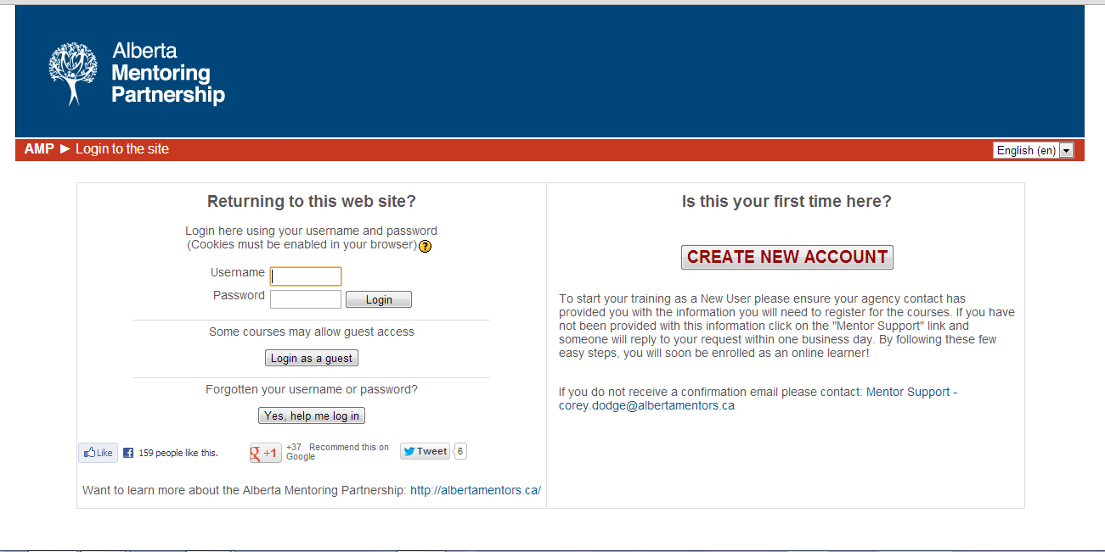

- Fill in your information. Choose an easy username that you will remember and be sure to write it down (example lastnamefirstname). Everything marked with an asterisk (*) is required.

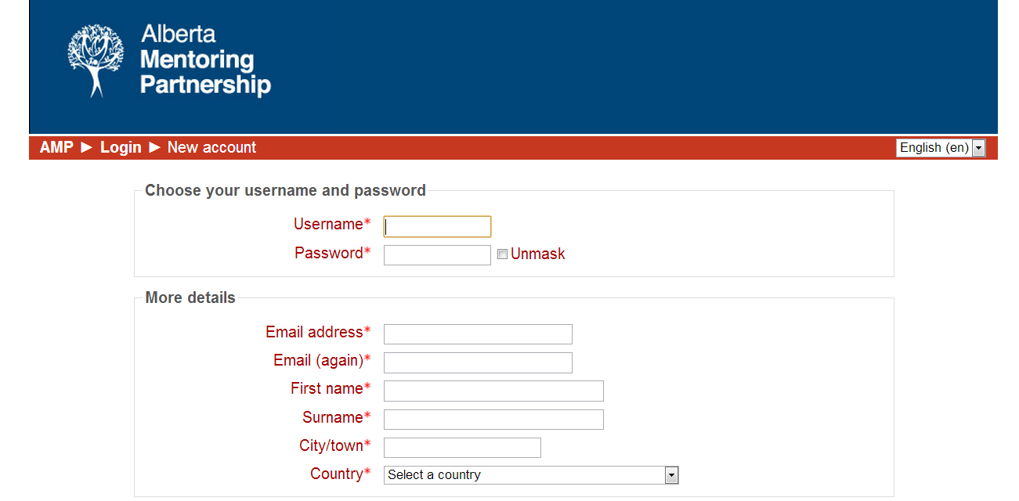

- Under Organization, choose your school’s name or ‘Other Authorized User’ if your school name is not on the list.

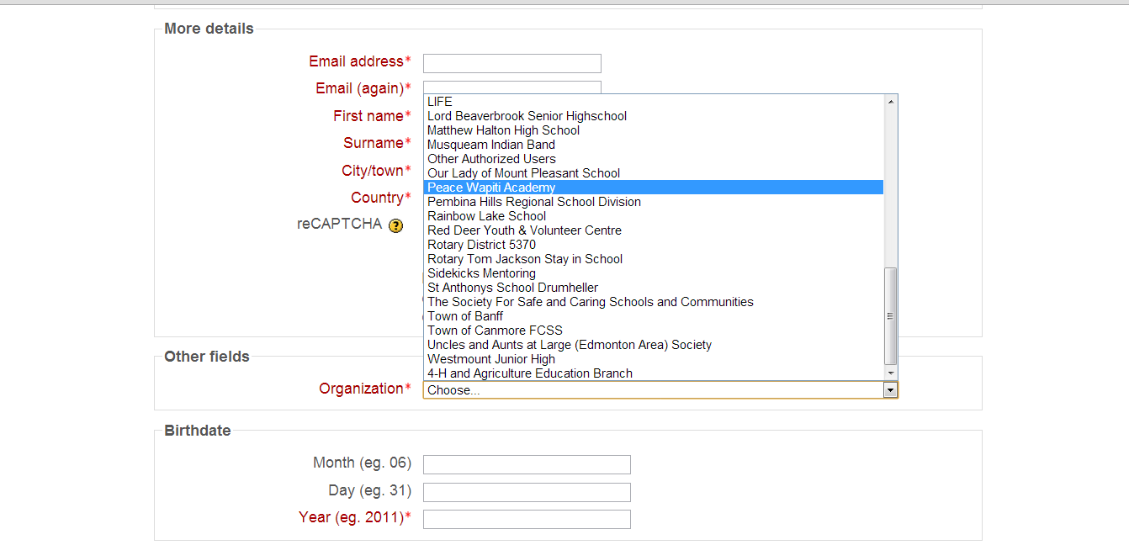

- Click ‘Create My New Account’

- A confirmation e-mail will be sent to your e-mail address provided with your login information.

- Click on the link ‘Orientation for Mentors’ to get started

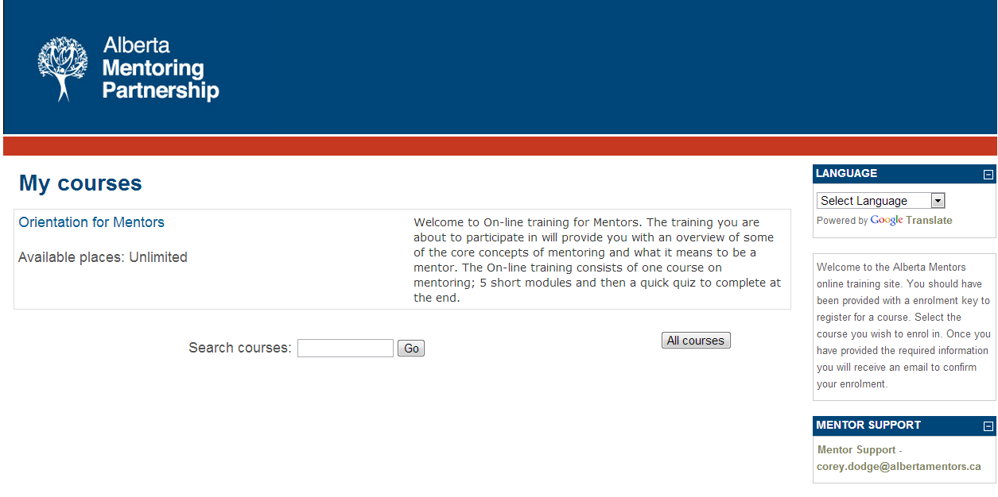
8. Once you have completed the modules and the quiz, you will be e-mailed a certificate of completion.

